EarthTeam Stars (ETS, or STRZ) Tokenomics

1. Overview
EarthTeam Star (ETS) is a purpose-driven token built on the Solana blockchain using the SPL token standard, facilitating transparent, efficient, and verifiable conservation action through tokenized incentives. ETS underpins a decentralized ecosystem promoting environmental impact via Proof-of-Impact (PoI) mechanisms.
A total of 510 million Stars will be minted, representing the same number of square kilometers covering Earth. EarthTeam seeks to incentivize and reward protectors across the entire planet, with the goal of spending this total amount by the end of 2030, corresponding to the deadline for reaching the globally agreed 30 x 30 Sustainable Development Goals. We are in a hurry to reverse biodiversity loss and climate change.

2. Token Specifications
Parameter | Value
Name | EarthTeam Coin
Symbol | ETS (or STRZ)
Blockchain | Solana
Token Standard | SPL
Total Supply (Capped) | 510,072,000 ETC
Decimal Precision | 6
Contract Audits | Yes (Third-party audit pre-launch)
Minting Function | Controlled, tied to verified impact only
Burn Mechanism | Yes (optional per governance vote)

3. Initial Token Allocation
Category | Allocation (%) | Token Amount | Unlock Schedule / Vesting
Ecosystem Incentives | 40% | 204,028,800 | Based on verified conservation activities via Proof-of-Impact (PoI).
Development & Operations | 20% | 102,014,400 | Linear vesting over 36 months. 3-month cliff.
Partnerships & Grants | 15% | 76,510,800 | Linear vesting over 36 months. 3-month cliff.
Reserve Fund | 10% | 51,007,200 | Locked for 12 months, then discretionary release.
Community & Marketing | 15% | 76,510,800 | 33% TGE, rest released over 24 months.

4. Utility and Use Cases
EarthCoin powers a green web3 ecosystem. Its uses include:
A. Incentivizing Conservation
- Reward verified ecological actions (tree planting, plastic removal, wildlife protection).
- Proof-of-Impact submission → On-chain verification → Token mint.
B. Access and Exchange
- Used to purchase eco-services or products on the decentralized Earth Marketplace.
- Exchangeable for stablecoins or used in ecosystem swaps.
C. Governance
- 1 ECT = 1 vote in on-chain governance.
- Used to propose, support, or vote on:
  - New impact categories.
  - Grant allocations.
  - Treasury usage.
D. Staking & Delegation
- Stake ETC to earn rewards (sourced from treasury or impact pool).
- Stakeholders can delegate tokens to verified organizations, signaling community trust.

5. Emission & Minting Mechanism
EarthCoin is partially inflationary, governed by Proof-of-Impact emissions:
Parameter | Details
Fixed Supply Cap | 510,072,000 ETC
Impact-Based Minting | Dynamic, but capped annually (e.g., 5% max/year)
Developmental Emission | Pre-minted, vesting over 3 years
Community Minting | Capped quarterly, subject to verified reach metrics

Proof-of-Impact Oracle Integration:
- Oracles verify real-world conservation efforts via satellite, IoT, or on-ground validators.
- Verified data triggers smart contract-based minting (from Ecosystem Incentive Pool).

6. Deflationary Mechanics (Optional)
To control inflation and increase scarcity:
- Burn on Use: Small % of tokens burned per marketplace transaction (governance-controlled).
- Penalty Burn: Inactive or fraudulent wallets (post-review) subject to slashing.

7. Governance Model
DAO-Driven Roadmap (EarthDAO):
- Token holders propose/vote on decisions including:
  - PoI eligibility and thresholds.
  - Treasury deployment.
  - Adjusting incentive models.
  - Partnership onboarding.
Participation Thresholds:
- Minimum token holding to propose: 100,000 ETC.
- Quorum: 10% of circulating supply.
- Supermajority (66%) for treasury actions.

8. Vesting & Release Timelines
Allocation | TGE (%) | Cliff | Vesting Schedule
Ecosystem Incentives | 0% | 0 | Released dynamically via PoI oracle
Development | 10% | 3 mo | Linear over 36 months
Partnerships & Grants | 10% | 3 mo | Linear over 36 months
Reserve Fund | 0% | 12 mo | Discretionary after lock
Community & Marketing | 20% | 0 | Remainder over 24 months

9. Security & Compliance
- Smart Contract Audits by leading firms (e.g., Halborn, OtterSec).
- KYC/AML for grant disbursement recipients.
- Transparent on-chain treasury reporting.

10. Roadmap Alignment
- Q4 2025: Token Launch, Initial Airdrops, Oracle Setup.
- Q3 2025: Earth Marketplace Alpha, DAO launch, staking live.
- Q4 2025: Partner Grants, Expanded impact categories, Mobile wallet support.
- 2026+: Cross-chain integration, Carbon credit interoperability.

11. Sustainability and Long-Term Value
- Value Correlation: ETC’s value grows with ecological credibility and adoption.
- Token Scarcity: Controlled minting + burns = net semi-deflationary.
- Stakeholder Alignment: Environmental orgs, individuals, and DAOs all benefit via PoI participation.
Appendix

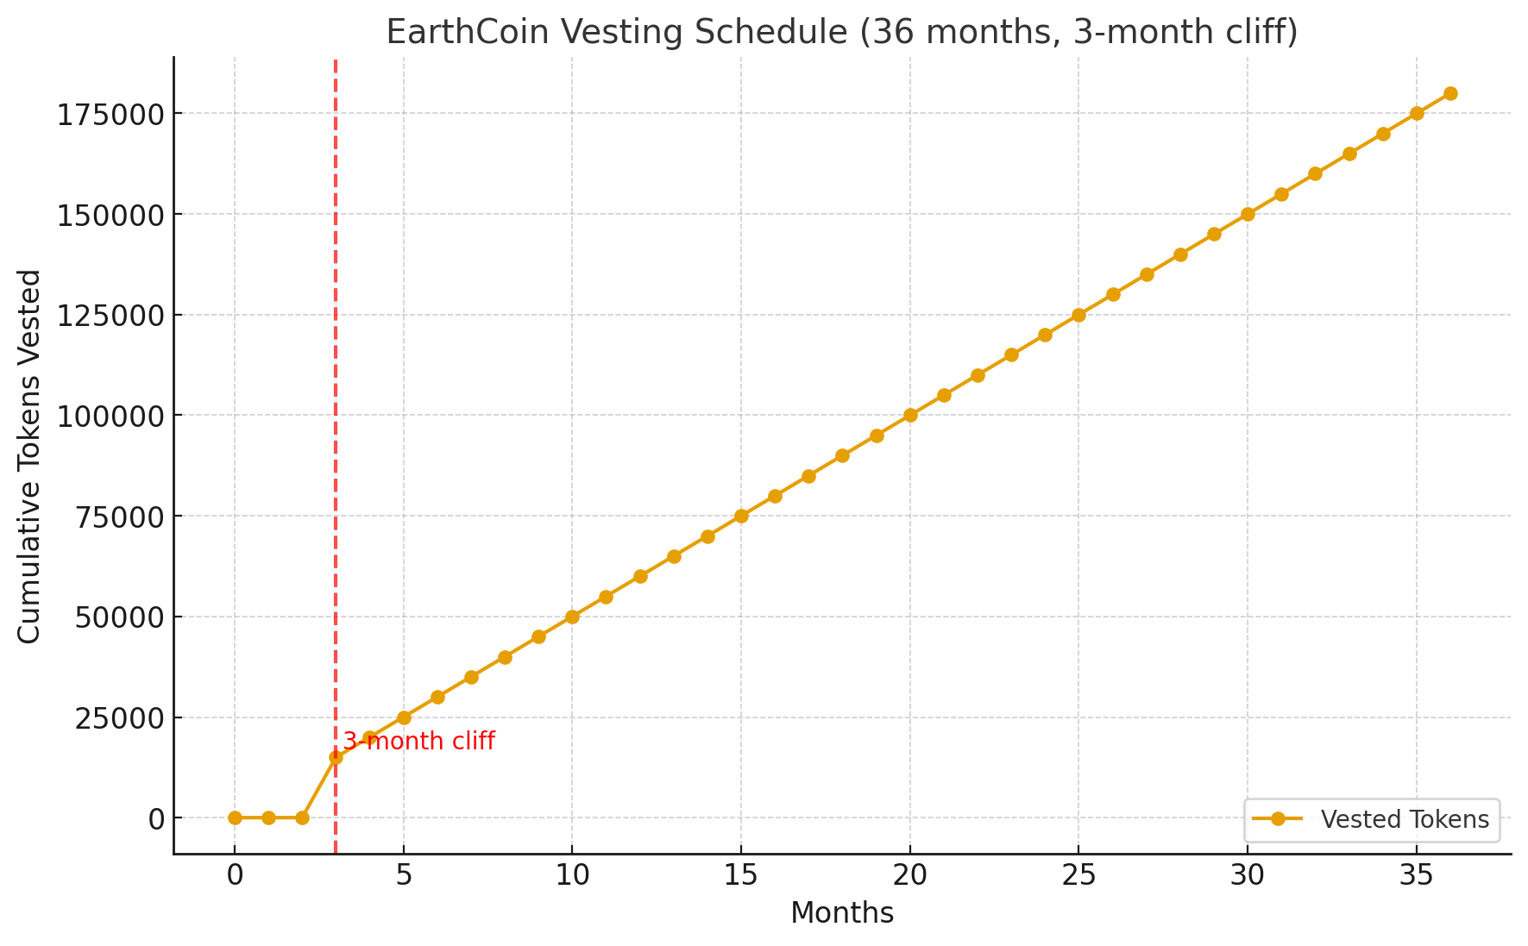
Chart 1: Visual of the vesting schedule for an EarthCoin allocation with 36 months linear vesting and a 3-month cliff:
- 📉 Months 0–2: No tokens vested.
- ⛰️ Month 3: A lump sum unlock (catching up the first 3 months).
- 📈 Months 4–36: Smooth monthly vesting continues until full allocation.

